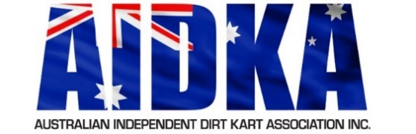**Director Application/Nomination Form**

The Australian Independent Dirt Kart Association Inc. (AIDKA) Board is responsible for the strategic leadership, direction and development of the sport. The skills mix of the Board must be aligned with the strategic direction and purpose of AIDKA.

Candidates wishing to apply as a Director of AIDKA should note the eligibility requirements and criteria set out in the AIDKA Board Charter.

Typed applications for Directors (submitted by e-mail) should include:

**• A completed Director Application/Nomination Form; and**

**• Working with children check or application for.**

*Please note upon successful appointment as a Director, each member will need to apply for an ASIC Director.*

|  |  |  |  |
| --- | --- | --- | --- |
| **Nominee’s name** |  | | |
| **Email Address** |  | **Telephone** |  |
| **Nominee’s Signature** |  | **Date** |  |
| **Nominated By** | *Name of AIDKA Member* | **Lic. No.** |  |
| **Seconded By** | *Name of AIDKA Member* | **Lic. No.** |  |

I hereby declare my consent for my interest to be recorded and communicated to all relevant persons within AIDKA.

|  |  |  |  |
| --- | --- | --- | --- |
| **Signature** |  | **Date** |  |

|  |
| --- |
| **NOMINATION/APPLICATION FORM** |
| Nominee Statement: *Reason and motivation for your interest in being a* *Director. (**issues or opportunities you may hope to address through your involvement)* |
|  |
| Specifically address how you can assist and improve AIDKA within the roles and responsibilities outlined in the AIDKA Board Charter. |
|  |
| Involvement in Sports Industry (any sports) |
|  |
| Involvement in AIDKA (incl. Board, Committee and Club Level experience) |
|  |
| Professional/Management Experience |
|  |
| Experience |
|  |
| Qualifications |
|  |

All applications must be submitted in writing to AIDKA Secretary via [secretary@aidka.com.au](mailto:secretary@aidka.com.au) and received by 5pm (ACDT) Wednesday 8th January 2025